**Creating a DSRC MAP Message by hand  
First Draft Rev10**

***Background:***

In this exercise we create a simple valid DSRC MAP message using common GIS tools, manual methods, and the ASN.1 editing tool called “ASN1 Viewer / Editor” Release 2.6.0 was used for this example,   
available from Objective Systems ( <https://www.obj-sys.com/>). SCSC recommends this tool as a good basic editor for validating and creating any of the SAE DSRC J2735 and/or J2945 messages, as well as the related IEEE 1609 work and ASN development in general.

This document is a work in progress at this point

The intersection chosen is the corner of **Dixon Landing Road and Milmont Drive** in Milpitas, California. This is near the offices of CETECOM Inc. who has hosted several recent SAE DSRC TC meetings.

This intersection can be displayed in Google with these links:

<https://www.google.com/maps/@37.4556441,-121.9170626,19.27z>

<https://www.google.com/maps/@37.4556441,-121.9170626,121m/data=!3m1!1e3>

Here is the Google image:

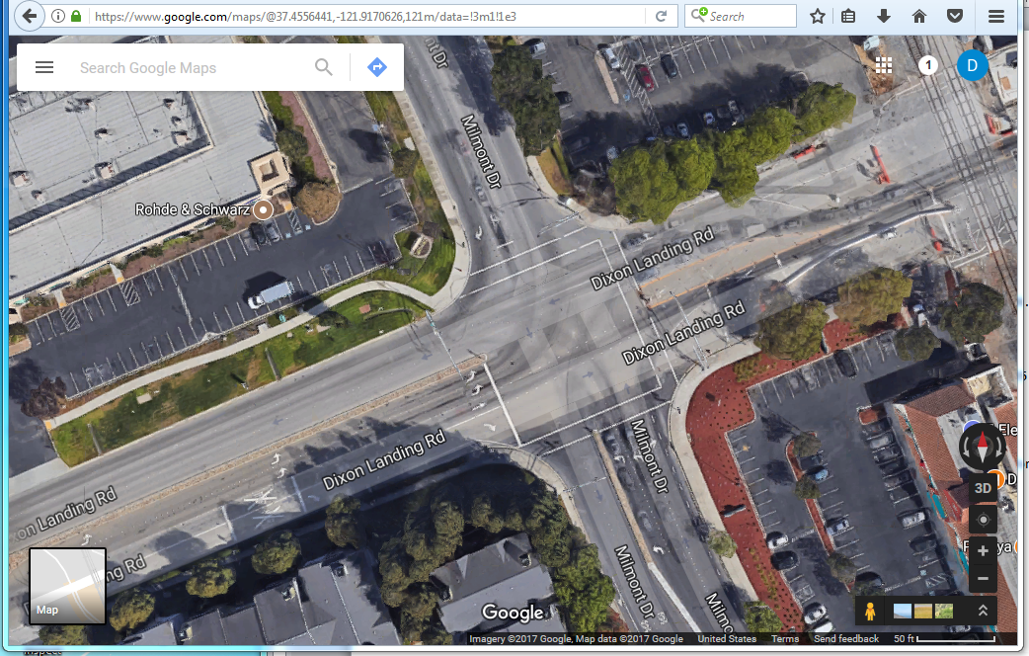

This represents a fairly typical four-approach intersection. We will refer to the lanes and approaches with terms like “west side” (for approaches on that side) and/or “west bound” (for lanes moving in that direction) even though the intersection is obviously rotated ~22 degrees CCW from the cardinal points.

**Observations and Simplifications:**

This intersection lacks many of the complications that result in more interesting maps. As a result it is a good candidate for teaching intersection best practices. Each of these lanes will be modeled for only ~25 meters back (300~1000 meters is more typical). As there are no curves present, most of the lanes will be represented as simple “two node point” lane objects. One lane (the west bound right turn lane) requires a 3rd node point due to a change in lane width. This intersection could be adequately modeled by the 2009 edition of the MAP message, as it makes very little use of Attributes. The support for a range of attributes associated with a lane was one of the major improvements made to the MAP message in the last two revisions. You can read more about the various features of the MAP message [here](http://dsrc-tools.com/map-spat/).

In this map no effort is made to field check the Google base map data. Therefore, the locations picked off the map are at best crude and are likely to be off by ~50cm or more, plus the base map error. Refer to **this article** for further details about registering a base map for accurate positional use.

This area is known to be fairly flat, so no use of vertical offset is made in the lanes. The anchor point height above the reference ellipse (which in fact is negative here) is taken from other map sources.

A common lane width of 305 centimeters (10 feet) appears to have been used in the roadway design.

When this intersection was captured by Google there was some short term construction taking place along the east side of the intersection in the west-bound lanes. Temporary barriers are visible in the images. These can also be modeled in the MAP message (as a type of median), but the message has been prepared without these.

There is a rail crossing further to the East of the intersection. The attributes needed to reflect this in the lanes are not provided. Refer to **this article** for further details about handling rail corssings.

**Lane Types Found:**

This intersection has four “stripe” lane objects in the no-man’s region, and these are not modeled. Refer to **this article** for further details about this lane type.

This intersection has three “median” lane objects, and these are not modeled. Refer to **this article** for further details about this lane type.

This intersection has both implicit and explicit “cyclist” lane objects on the southern side, and these are not modeled. Refer to **this article** for further details about this lane type.

This intersection has eight “sidewalk” lane objects, and these are not modeled. Refer to **this article** for further details about this lane type.

This intersection has three Pedestrian Crosswalks; these will be modeled and are treated as a single approach group. Refer to **this article** for further details about this lane type. Refer to **this article** for further details about approach groups.

This intersection has 21 Motor Vehicle lanes, consisting of 12 ingress lanes and 9 egress lanes. The ingress lanes will be modeled (and the egress lanes as well if resources allow). Refer to **this article** for further details about this lane type. There are 38 lane objects in all.

**To begin**

We first review the map, one approach at a time, to determine what sorts of lane objects will be required and to assign an initial numbering system (and a fixed number) to each. As a guideline; it is very useful to sketch out the whole intersection before starting to design individual lane objects.

The approaches are numbered in a clockwise manner (as describe further here). Of more interest in this effort (as the resulting approach number of not used), is the resulting lane ID allocation of 16 lane numbers for each approach. General use of the *LaneId* in maps is discussed in **this article**.

*The North Side Approach [Lanes 0x10 to 0x1F]*

Here is a rotated view of the approach to allow easy lane numbering as per the best practices which are further described **here**.

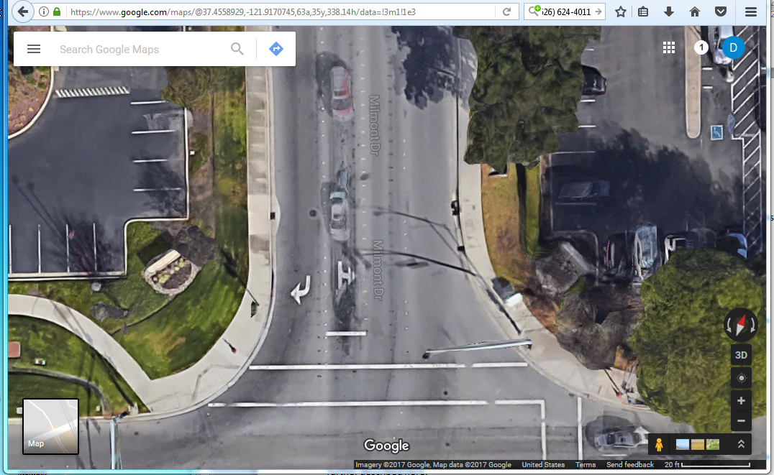

Because we always number all possible lane objects, the sidewalk becomes lane 0x10, the right turn lane is 0x11, and the ahead and left turn lane is 0x12, while the two egress lanes are numbered 0x 13 and 0x14. The final (right most in this image) sidewalk is numbered 0x15. The crosswalk is numbered 0x50. **There are 7 lanes defined and 3 lane objects to be modeled.**

Note that there is an implicit stop line for the left turn lane, projected from the painted stop line present in the other lane. Note that the right side (eastern corner) crosswalk is of the type that ends in the roadway. There are many common crosswalk styles, **this article** further discusses how to model the most common types.

*The East Side Approach [Lanes 0x20 to 0x2F]*

Here is a rotated view of the approach to allow easy lane numbering as per the best practices which are further described **here**.

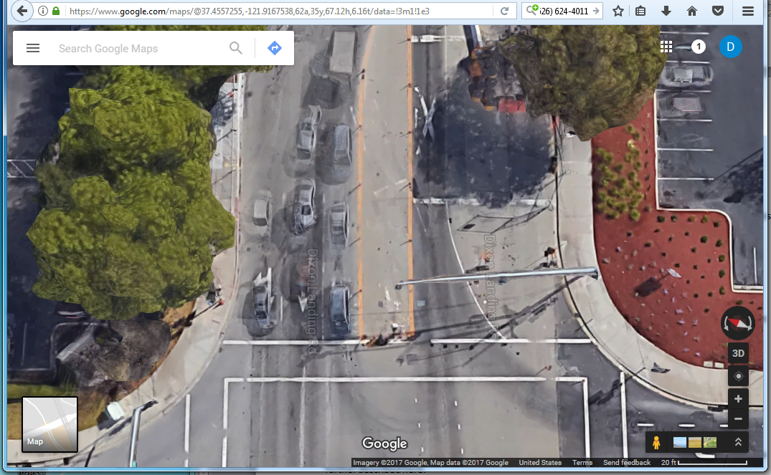

***UPDATE***: A second ahead lane was added due to current construction and the map adjusted to suit.  
To repeat, because we always number all possible lane objects : the sidewalk becomes lane 0x20, the right turn lane is 0x21, the 1st ahead lane is 0x22, the 2nd ahead lane is 0x23, and left turn lane is 0x24. The (now very thin) median is 0x25 (but not modeled), and the two egress lanes are numbered 0x 26 and 0x27. The final (right most in this image) sidewalk is numbered 0x28. The crosswalk is numbered 0x51, as it is the second one added to the approach. **There are 10 lanes defined and 5 lane objects to be modeled.**

Note that there is no stop line for these lanes, so we will project from the back edge of the crosswalk. This is common judgment call. Note again that the crosswalk is of the type that ends in the roadway.

*The South side Approach [Lanes 0x30 to 0x3F]*

Here is a rotated view of the approach to allow easy lane numbering as per the best practices which are further described **here**.

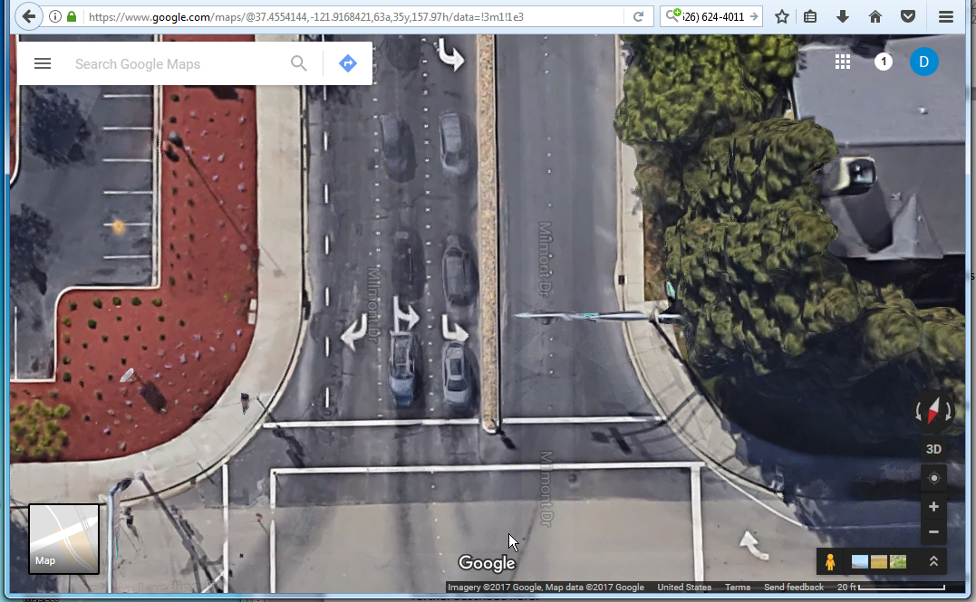

The leftmost sidewalk becomes lane 0x30, the bicycle lane is 0x31, the right turn lane is 0x32, the ahead and left turn lane is 0x33 and inner left turn lane is 0x34. The median is 0x35 (but is not modeled), and the two egress lanes are numbered 0x 36 and 0x37. There is also an outbound bicycle lane present, which is 0x38 (the striping begins right off the screen). The final (rightmost in this image) sidewalk is numbered 0x39. The crosswalk is numbered 0x52, as it is the third (and final) one added to that approach. **There are 11 lanes defined and 4 lane objects to be modeled.**

Note that there is no stop line for these lanes, so we will project from the edge of the crosswalk. This is a common judgment call. Note again that the crosswalk is of the type that ends in the roadway.

By now it should be somewhat evident that automation can be employed for this numbering process.

*The West side Approach [Lanes 0x40 to 0x4F]*

Here is a rotated view of the approach to allow easy lane numbering as per the best practices which are further described **here**.

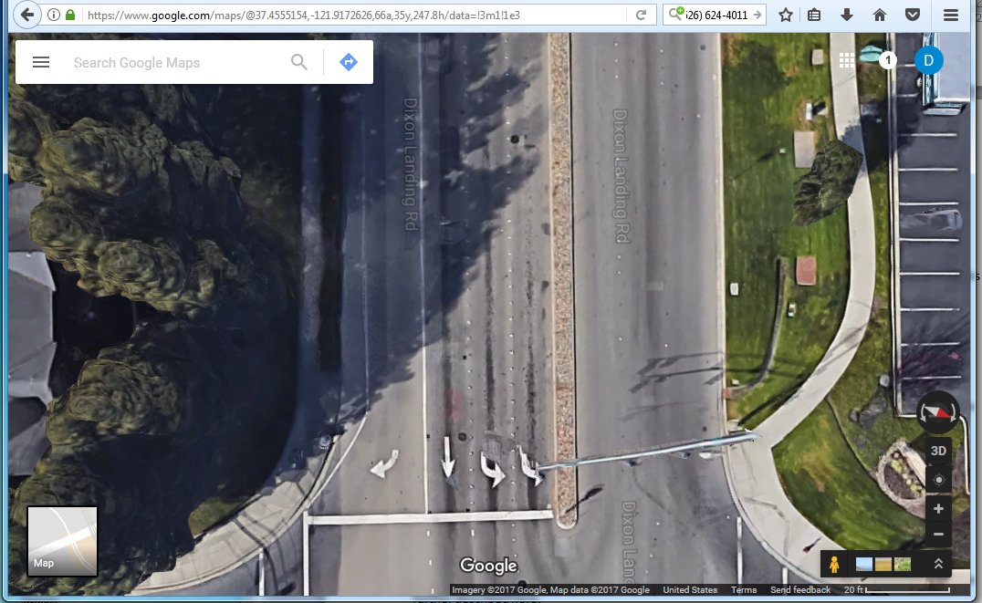

The leftmost sidewalk becomes lane 0x40, the bicycle lane with a taper (because it is solid it is perhaps a median) is 0x41, the right turn lane is 0x42, the ahead lane is 0x43, the outer left turn lane is 0x44 and inner left turn (to the right side in the image above) lane is 0x45. The median is 0x46 (but is not modeled). There are three egress lanes, numbered 0x 47, 0x48, and 0x49. The final (rightmost in this image) sidewalk is numbered 0x4A. Numbering this item at all is clearly a judgment call, as the path is not along the roadside. There is no crosswalk present. **There are 11 lanes defined and 4 lane objects to be modeled.**

Note the solid white stripe between the right turn lane and the ahead lane, indicating that crossing between the lane at that segment is prohibited or ill advised (in some States that is advice, in other it is normative). The Lane object attributes does allow reflecting this detail; this point is ignored for this simple example. Refer to **this article** for further details.

Note that there is (again) no stop line for these lanes, so we will project from the edge of the crosswalk. There is also a very slight lane skew present on these lanes which we will ignore in this example. This is a common judgment call. In more egregious example of skew the angle must be modeled; [this article](http://dsrc-tools.com/map-spat/index.php/knowledge-base/adding-lane-skew-stop-line/) serves to describe the more lane skew types and how it is modeled. Note that the egress lanes here are three in number, with the northern approach feeding the rightmost one. Therefore there is some slight weaving occurring from the East side to the West side on the no-man’s land in this intersection.

*The Crosswalk Approach [Lanes 0x50 to 0x5F]*

The three crosswalks shown in the above are given LaneId values taken from this range.

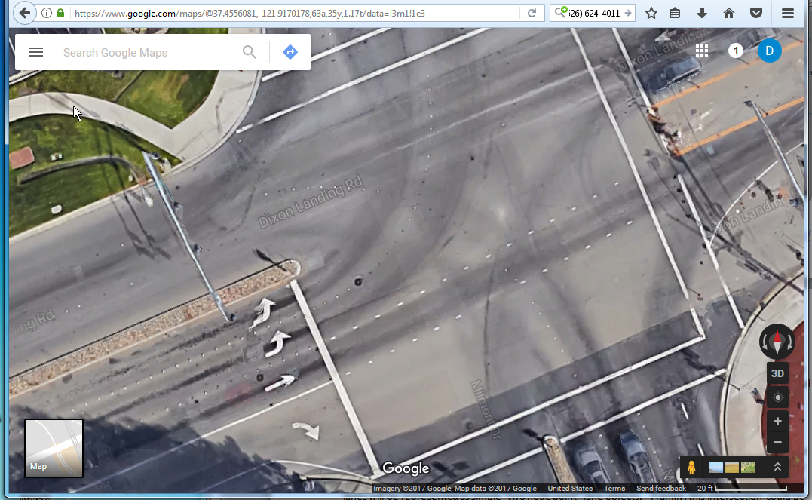

The three crosswalks lane IDs are numbered 0x50, 0x51, and 0x52 in a clockwise direction from the top (North) side.

Summarizing these lanes in a table form we have:

|  |  |  |  |  |  |  |  |  |  |
| --- | --- | --- | --- | --- | --- | --- | --- | --- | --- |
| Approach | Lane Cnt | Motor Lanes | Ingress | Egress | Cross-walks | Bike Lanes | Side-walks | Medians | To Model |
|  |  |  |  |  |  |  |  |  |  |
| North | 7 | 4 | 2 | 2 | 1 | 0 | 2 | 0 | 3 |
| East | 10 | 6 | 4 | 2 | 1 | 0 | 2 | 1 | 5 |
| South | 11 | 5 | 3 | 2 | 1 | 2 | 2 | 1 | 4 |
| West | 11 | 7 | 4 | 3 | 0 | 1 | 2 | 1 | 4 |
|  |  |  |  |  |  |  |  |  |  |
| Totals | 39 | 22 | 13 | 9 | 3 | 3 | 8 | 3 | 16 |

**The basic ASN needed**

With the graphical references to the intersection already provided, we can now develop a valid but otherwise “empty” ASN message. From that point we can then add the data values needed, including the LLH (Latitude, Longitude, Height) values which will be captured with common GIS XML/KML tools.

In each of the cases that follow, the XML expression is shown. The binary message (encoded in correct UPER form) is also noted and available in the supporting files.

*The basic message frame*

All J2735 messages live within a top layer structure called the *MessageFrame*. It is the octet “aligned” bytes of this ASN production that are the Protocol Data Unit (PDU) handed to the 1609 layer (or any other transport) that are encoded and conveyed to the other end. The “signing” of this data by the security certificate is handled at this layer as well as binding any SSP data required for sender permissions. This is not intended to be a tutorial on the DSRC protocol stack; review the information found **here** for further details.

The MessageFrame requires that the internal message type be defined. The ASN specification uses the parameter methods now found in the ASN of the J2735 standard. It should be mentioned in passing that some free ASN tools cannot process such messages with parameters at this time.

Once a message has been selected, the **MapData** message in this case, the resulting XML is very terse showing only the minimal required ASN elements, in this case no actual useful content:

<MessageFrame>

<messageId>18</messageId>

<value>

<MapData>

<msgIssueRevision>1</msgIssueRevision>

</MapData>

</value>

</MessageFrame>   
[Size: 40 Bits, File: EmptyMapMessage.uber]

**Note**: This basic empty message is a “valid” and well formed ASN message from an ASN protocol perspective, but not from an SAE J2735 normative conformance statement prospective (see Clause 11 of the J2735 standard). Depending on the decoder design, any OBU getting such data should be able to decode at the ASN in any event. All of the code examples provided here represent valid ASN in this respect.

The matching binary message is shown with the file label above, as well as the message size in bits.

*One intersection in the Map MESSAGE*

The **MapData** message can in fact contain multiple maps and map types. It is intended to be a container structure. Both general purpose maps (called roadSegments and used for various needs) and intersections are supported. Some pilot deployments plan to exploit this to providing nearby intersection maps to the OBU devices before they come into reception range for the RSU at the next intersection. Devices need to be prepared to test for this as well.

A MessageFrame with a MapData message containing one single intersection looks like this (this is an image from the editing tool being used):

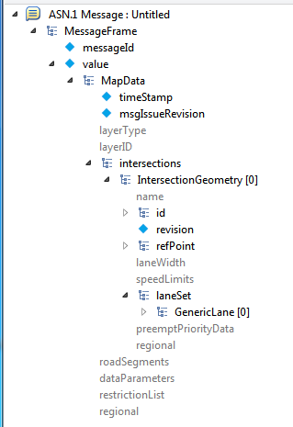

**Display of One Intersection with no content within the MapData message**

At this point there are several required values with default values, and the XML listing becomes rather large. Much of the apparent bulk is because all intersections have all least one lane, and every lane has at least two node points. So the ASN format requires these minimal elements to be present.

<MessageFrame>

<messageId>18</messageId>

<value>

<MapData>

<timeStamp>0</timeStamp>

<msgIssueRevision>1</msgIssueRevision>

<intersections>

<IntersectionGeometry>

<id>

<id>123</id> 🡨 Assigned in the “test” range

</id>

<revision>0</revision>

<refPoint>

<lat>-900000000</lat>

<long>-1799999999</long>

</refPoint>

<laneSet>

<GenericLane>

<laneID>0</laneID>

<laneAttributes>

<directionalUse>00</directionalUse>

<sharedWith>0000000000</sharedWith>

<laneType>

<vehicle>00000000</vehicle>

</laneType>

</laneAttributes>

<nodeList>

<nodes>

<NodeXY>

<delta>

<node-XY1>

<x>-512</x>

<y>-512</y>

</node-XY1>

</delta>

</NodeXY>

<NodeXY>

<delta>

<node-XY1>

<x>-512</x>

<y>-512</y>

</node-XY1>

</delta>

</NodeXY>

</nodes>

</nodeList>

</GenericLane>

</laneSet>

</IntersectionGeometry>

</intersections>

</MapData>

</value>

</MessageFrame> [Size: 272 Bits, File: EmptyIntersection.uber]

In the above you will also see the use of various predefined values such as

<node-XY1>

<x>-512</x>

<y>-512</y>

</node-XY1>

In this case the value “-512” is used to indicate an unknown value (see Clause 7.118) In practice, there is never any reasons an intersection MAP would be issued with such a value.

In the above you will also see the use of various predefined values such as

<lat>-900000000</lat>

<long>-1799999999</long>

This is because the tool we are using will select as an initial value the first valid value in the allowed range. For signed integers, this means the lowest valid number. There are a number of values assigned for concepts like “value not known” or “value not valid” which are defined in the J2735 standard. Often these are the largest number range allowed. A better message instance might start with all such required data values set to the “not valid” number. In the above case, the invalid values would be set to:

<lat>900000001</lat>

<long>1800000001</long>

Before we add the lanes to this structure, another key data item bears mention: Each Intersection in the Map has an anchor point, expressed in LLH coordinates which serve to tie the orthogonal XYZ coordinate system used by each intersection map to the ellipsoidal WGS84 coordinate system used by BSMs and other messages. This is a somewhat complex topic area and is explained further in **this article**. The location selected is best chosen as a mathematical abstraction of the lane coordinates and not some sort of physical benchmark at the intersection. This is another complex topic, see **this article** for details. The node offsets are all described from this common position, which is treated as the origin, but we will ignore that detail for the moment.

Two useful but optional data element are missing from the above, the “name” and the default “laneWidth” entries. The width serves as a common value (always 16 bits) so that lane width data need not be repeated in each lane sharing the value.

The name string is intended *only* for testing uses, but it may be helpful here to detect it with wireshark or other tools. When we add a name string of “Dixon-Milmont” and a default laneWidth (of 305 cm) to the message, the size grows to 384 bits (because of the 104 bits added to convey the string). The resulting file is called: EmptyIntersectionNamed.uper.

*Adding the Empty Lanes*

This intersection has 39 known and numbered lane objects, of which we have elected to model 16(13 motor vehicle lanes and 3 pedestrian crosswalk lanes). All but one of these will be 2-point lanes. One lane will be a three point lane, the right turn line on the western side, lane 0x42. In that lane’s case an additional node offset point is needed to express the way the lane width flares at the stop line.

**Side note**: In any automated tool one would expect to be able to click on a node segment when editing its geometry and “break” the segment to create a new node when the need becomes apparent. Most GIS tools support this concept in various ways, as do early DSRC Map editing tools. Here, because we are developing the MAP with manual methods, we simply create 16 new empty Generic Lane objects as a laneSet.

We also enable the “maneuver’s“data element in each lane. This element is a collection of all allowed maneuvers one can make at the stop line (i.e. turn left, go ahead, make a u-turn, etc.). The topic of the set of defined “allowed maneuvers” is discussed further **here**. For this example we skip over the issue of allowed maneuvers which vary by time of day. The topic of the set of allowed maneuvers which vary by the time of data is discussed further **here**.

At this time we do not yet add the ConnectTo data frame. The ConnectTo structure connects the Lane to the signalGroup(s) (i.e. which signal head (light) that controls it). From this, which SPaT message pertains to it can be determined. It also (optionally) connects the end of the lane (the Stop line) to the next lane and states what one maneuver is used to get there. The topic of how to construct ConnectTo data frames is discussed further here.

We then hand edit the laneID value used for each lane to match the work developed above.

Three of these lane objects are not motor vehicle lanes (which is the default style) so we edit them to be Pedestrian Crosswalk lanes. Note that these were placed last in the message numbering, but that there is no overriding technical or best practice reason for this choice. Deployments must be prepared to accept the GenericLane entries in any order. It is fairly simple to scramble the lanes for testing needs. If still needed, a more extensive review of the various lane types is provided **here**.

For one lane (laneID = 0x42) we add a 3rd node point to allow changing the lane width. It is also obvious from inspection that this lane is wider than the others, but we do not add a new attribute (which would be in placed the nodeList) for this need at this time.

The resulting XML listing is rather large (476 lines), so a very cut down copy is provided below showing only two of the Generic lane Objects. One is a motor vehicle lane; the other is a crosswalk lane.

The complete listing can be found in the file: IntersectionWithLanes.xml

<MessageFrame>

<messageId>18</messageId>

<value>

<MapData>

<timeStamp>0</timeStamp>

<msgIssueRevision>0</msgIssueRevision>

<intersections>

<IntersectionGeometry>

<name>Dixon-Milmont</name>

<id>

<id>123</id>

</id>

<revision>0</revision>

<refPoint>

<lat>900000001</lat>

<long>1800000001</long>

</refPoint>

<laneWidth>305</laneWidth>

<laneSet>

<GenericLane>

<laneID>18</laneID>

<laneAttributes>

<directionalUse>10</directionalUse> 🡨 in bound

<sharedWith>0000000000</sharedWith>

<laneType>

<vehicle>00000000</vehicle>

</laneType>

</laneAttributes>

<maneuvers>001000000000</maneuvers> 🡨 left turn

<nodeList>

<nodes>

<NodeXY>

<delta>

<node-XY1>

<x>-512</x>

<y>-512</y>

</node-XY1>

</delta>

</NodeXY>

<NodeXY>

<delta>

<node-XY1>

<x>-512</x>

<y>-512</y>

</node-XY1>

</delta>

</NodeXY>

</nodes>

</nodeList>

</GenericLane>

<GenericLane> - cut -

<GenericLane>

<laneID>80</laneID>

<laneAttributes>

<directionalUse>11</directionalUse>

<sharedWith>0000000000</sharedWith>

<laneType>

<crosswalk>0000000000000000</crosswalk>

</laneType>

</laneAttributes>

<nodeList>

<nodes>

<NodeXY>

<delta>

<node-XY1>

<x>-512</x>

<y>-512</y>

</node-XY1>

</delta>

</NodeXY>

<NodeXY>

<delta>

<node-XY1>

<x>-512</x>

<y>-512</y>

</node-XY1>

</delta>

</NodeXY>

</nodes>

</nodeList>

</GenericLane>

<GenericLane> - cut -

<GenericLane> - cut -

<GenericLane> - cut -

<GenericLane> - cut -

<GenericLane> - cut -

<GenericLane> - cut -

<GenericLane> - cut -

<GenericLane> - cut -

<GenericLane> - cut -

<GenericLane> - cut -

<GenericLane> - cut -

<GenericLane> - cut -

<GenericLane> - cut - 🡨 due to construction, needed 1 more

</laneSet>

</IntersectionGeometry>

</intersections>

</MapData>

</value>

</MessageFrame> [Size: 1824 Bits, File: IntersectionWithLanes.uber]

At this point each Generic lane Object has been numbered and has empty (and therefore slightly smaller) node data sets. The various lane Attributes remain to be further edited for each entry. Keep in mind the size here is expressed in bits, not in bytes (so 228 bytes).

While this message contains no geometric data and only minimal attribute data, any RSU and OBU getting such data should be able to fully decode it without problems.

**Setting the Per Lane Attribute Data…**

This part of the process is best managed by building a table of the desired values *before* creating the ASN representation. The table format used by SCSC is shown in the tab called ***Lane Attributes*** in the supporting spreadsheet.

This information was partially completed and then fitted to the XML/ASN above in order to complete that step. To be more specific, the LaneID, the lane type, the direction of use, and some of the Maneuvers section were completed, while the Lat-Long data was developed elsewhere (discussed below).

There are a great many other attributes here which can (or must) be asserted for different conditions. We ignore these for this simple example but they are reviewed in more depth here.

Image of worked table to go here

Image of worked table to go here

Image of worked table to go here

Image of worked table to go here

Note that these are the constant attributes for the *entire* lane object. They are not the same as the “node level” attributes which may be inserted at any node offset point. The two concepts are different. In this simple example we only have one node level attribute, the change in lane width which is needed by laneID 0x42.

**And now the Actual Geometric Data…**

The objective here is to gather the two latitude and longitude point values needed by each of the 15 lane objects we will model. In other words, 31 key values (because the one node has a 3rd point) are needed to fill out the lane paths in the message. In the next section we will process these values into a format suitable for use in the DSRC MAP message.

Several approaches may be used for this with different tools ranging from free to rather costly. Many of these tools will draw a polygon center line and then export the resulting data in open formats like KML which a human can then read. Many people initially think that capturing this data is a first step, but as the prior 15 pages demonstrate, it is more of a mid-stage process. With more complex maps, a considerable amount of attribute editing then takes place to “hang” data on the resulting positions.

Here we perform this with X times with (X is tbd) different tools to demonstrate that the data capture can be performed in many ways. The unique needs of DSRC MAP development are expected to be integrated into existing GIS tool suites,generally along the steps outlined here. As people become more aware of DSRC’s unique needs, we at SCSC expect to see plug-in modules to the many existing GIS tools. Here is a link giving a quick review of several such tools you may care to employ for this capture step (<http://gisgeography.com/mapping-out-gis-software-landscape/>). None of these tools provide any DSRC specific features to date, but nearly any of them can be used in the fashion outlined here.

**First (worked) solution**

In this initial draft we have used some in-house tools based on Global Mapper and base map imagery we have the rights to. Unlike the Google based images used before, we can overlay lines as we see fit.

**Late breaking news--the current construction at this intersection has caused some issues with the East side lane layout. Now this example has become one where the lanes are different on two base maps.**

Replotting the intersection with this imagery, we see a very similar image:

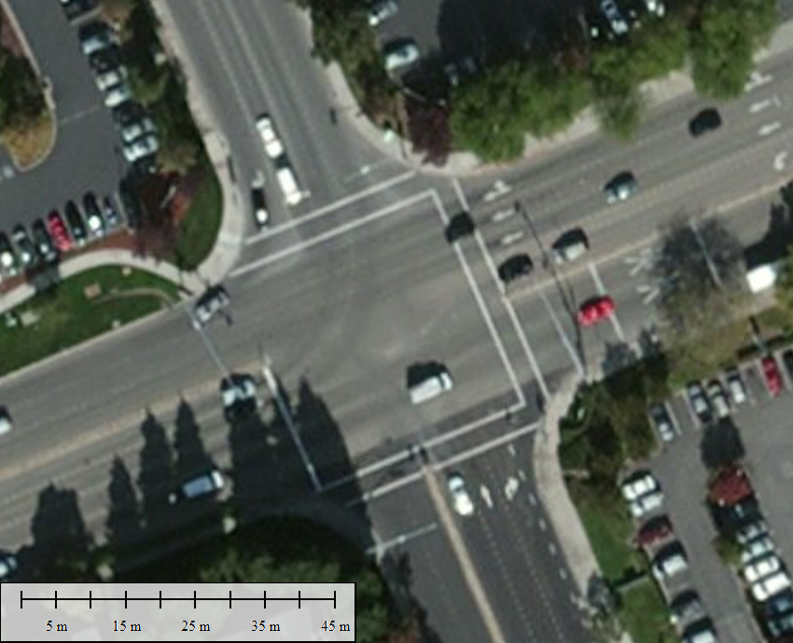

In order to use this image we need to establish some key control lines that will be useful as we zoom into the image and select the precise points for the lane objects. When zoomed into these sorts of raster images without the control lines it is easy to become lost. Unlike Google, other GIS tools do not limit the amount you can zoom by, but obtaining good raster data with pixel sizes under ~6 inches can be difficult and very costly in many places. The support web page has a good example of this **here**.

Here is the same map with the control lines we normally use shown. The setback stop lines (when present) and crosswalk edges are often used for this. You can see that we make a choice to extend that inbound stop line to the opposite side, effectively creating a stop line (and hence the 1st node point) for the egress lanes. There is not enough field experience to suggest this should be a recommended best practice, but seems to work well so far. In a similar fashion the control lines for the pedestrian crossing are extended to allow determine where opposing crosswalks would intersect. We recommend that crosswalks be extended in this way and typically at least a meter past the curb edge. See **this article** for details of how to establish such construction lines.

Note also that you can also see we have placed the DSRC MAP Anchor point in the middle of the intersection. We stress again that this is just a mathematical convenience. See **this article** for details.

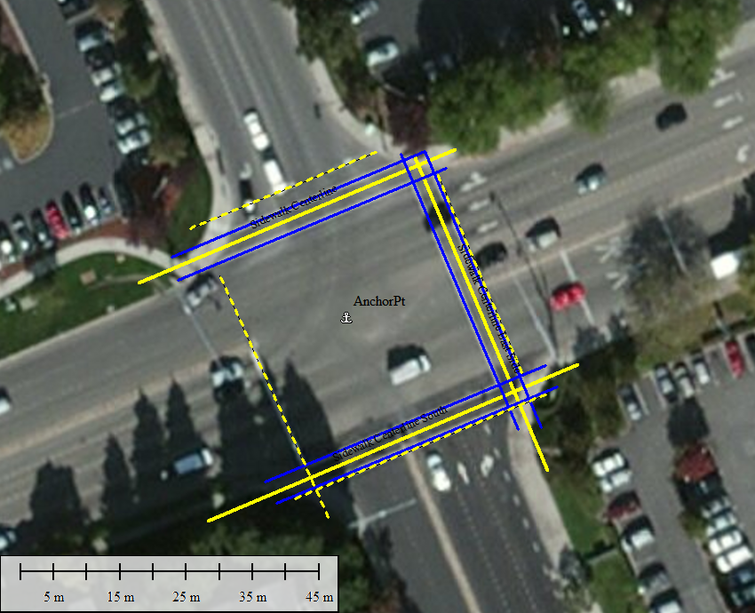

Given these control layers to guide us, we can now create centerlines for each of the lane we care to model. These are displayed as lines, but in fact keep in mind they are polygons. [We are now working to update an older tool from the prior MAP message formats to automatically transform one to the other for visual uses]

The precise steps used to produce the below image will vary with the tool used.

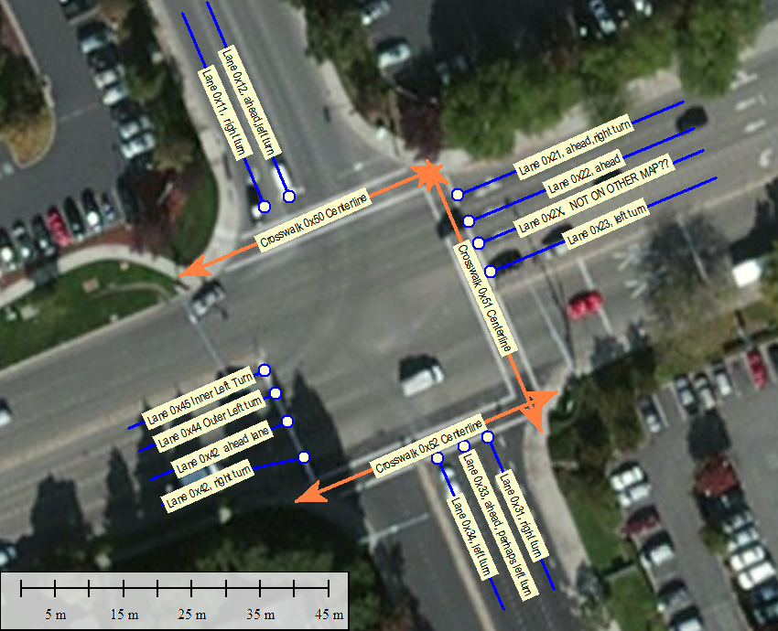

This consistent naming convention gives each path that is developed with the GIS tool an easy way to locate it when the data is exported from the tool into KML/XML/JSON etc.

The final information is shown below. On the MAP-SPAT web site these images can be found overlaid with a slider bar for easy comparison. **Temp note**: here is a [web page](http://dsrc-tools.com/map-spat/index.php/knowledge-base/slider-testing/) showing this effect, still in development.

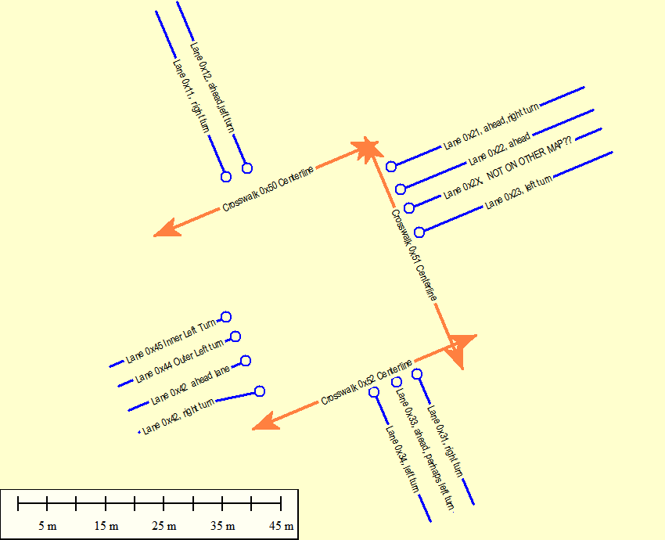

The key Path Data Need for the ASN message

*Capturing the center lines*

After much work, we can now export the resulting line values shown above into many different file formats. KML (a flavor of XML will be used here), but JSON (GeoJSON) and many dozens of other formats can be used. Most GIS tools can also create files which you can then use (import) with Google and Bing tools as well.

Here is a fragment of the resulting file, showing the motor lanes on the West side approach. The full file is named JustLanes.KML and is found with the other supporting files.

<Document>

<Folder>

<!-- **NOTE** Content removed here -->

<Placemark>

<description>SCSC_MotorLane</description>

<name>Lane 0x45 Inner Left Turn</name>

<styleUrl>#line3</styleUrl>

<LineString>

<coordinates>

-121.9171117741,37.4555902388,0

-121.9173281714,37.4555178043,0

</coordinates>

</LineString>

</Placemark>

<Placemark>

<description>SCSC_MotorLane</description>

<name>Lane 0x44 Outer Left turn</name>

<styleUrl>#line3</styleUrl>

<LineString>

<coordinates>

-121.9170954148,37.4555608022,0

-121.9173118121,37.4554883676,0

</coordinates>

</LineString>

</Placemark>

<Placemark>

<description>SCSC_MotorLane</description>

<name>Lane 0x42 ahead lane</name>

<styleUrl>#line3</styleUrl>

<LineString>

<coordinates>

-121.9170762511,37.4555257762,0

-121.9172926484,37.4554533417,0

</coordinates>

</LineString>

</Placemark>

<Placemark>

<description>SCSC_MotorLane</description>

<name>Lane 0x42, right turn</name>

<styleUrl>#line3</styleUrl>

<LineString>

<coordinates>

-121.9170499573,37.4554803406,0

-121.9171395434,37.4554652486,0

-121.9172734846,37.4554201788,0

</coordinates>

</LineString>

</Placemark>

</Folder>

</Document>

</kml>

It is obvious in the above which ”<Placemark>” entry is which lane due to the naming pattern used.

**Aside**: It would be very useful for the larger community to develop a more standardized way to represent our lane data in KML and/or JSON so that GIS tool makers could share such data with a common interface. This is not something that the SAE DSRC TC is likely to lead

In the absence of a suitable way to edit the lane further (notably to add and adjust attributes), we are now essentially done with the GIS processing part of the process. However, in most MAP creation projects that this author has been a part of, one returns to the GIS stage for additional tweaks in the captured data. The need is most often driven by better data to correct the map, or by mistakes in the layout process.

*Creating a table for values*

And now we can take these points from the GIS tool and place these point values into an Excel table for further review and processing needed to translate the full LLH values into localized XYZ offsets. The process at this point involves extracting the LL location by hand, although this process could be (and has been) easily automated.

In the attached spreadsheet, on tab “Rough Line Pts” entry, the above XML data is transformed into a well sorted table with the LL points required for each lane. Here are the first two points of this table, once formatted, as a terse example:

|  |  |  |  |  |  |  |
| --- | --- | --- | --- | --- | --- | --- |
| **Lane** | **First Point** |  |  | **Second Point** |  |  |
|  | Long | Lat |  | Long | Lat |  |
| **Crosswalk 0x50 Centerline** | |  |  |  |  |  |
|  | -121.9168331873 | 37.4558475627 |  | -121.9172456337 | 37.4557099312 |  |
|  |  |  |  |  |  |  |
| **Crosswalk 0x52 Centerline** | |  |  |  |  |  |
|  | -121.9166512286 | 37.4555634224 |  | -121.9170636750 | 37.4554257904 |  |

This brings up two interesting practical points to consider when creating such tables.

First, the order of the elements expressed in KML of many GIS tools is often not controllable. So the naming pattern used to denote each feature becomes very important in the process of identifying each correct data element. In the case of the tool used here, the crosswalks were “drawn” first so they were exported first.

Second, the order in which the point is expressed in the XML may vary regarding which end of a line or polygon path is expressed first. In the case of crosswalk lanes, this is of less importance, as each tends to be an equal distance from the anchor selected. But it becomes vital in the case of motor vehicle lanes, which are always described from the stop line out away from the intersection.

It is good idea to review the resulting table of data elements for such things before proceeding.

*Translating LLH to local offsets*

The next step in the process is to determine the deltas of latitude and longitude from the anchor and from the prior point in each sequence. This is simple math but it is important to keep in mind that the sign of each offset is the distance needed to move from the current point to the next point.

The delta for the first node point is from the common anchor. For the second node point it is from the 1st node point, etc. This simple encoding method was chosen to reduce the overall message size, although it should be pointed out that one of the allowed encoding of the MAP involves send a full 320bit LL value with each point.

It is easy to construct additional entries in the table to resent the LL offsets, as shown below. We then need to convert the localized LL values to units of centimeters for the orthogonal XYZ map. In order to do this we employ the Vincenty method to obtain the conversion factors needed. This process is discussed further in **this article**, and the *LL Conversion tool* used is available **here**. The critical two values are as follows:

|  |  |  |  |
| --- | --- | --- | --- |
| **The Defined Anchor Point to use:** | | |  |
|  | Long | Lat |  |
|  | -121.9169660866 | 37.4556439159 |  |
| cm per degree | |  |  |
|  | 8847730.8 | 11099564.5 |  |

The units in the above are expressed in a slightly odd format from the normal DSRC use to aid in the spreadsheet. To briefly recap, in the world of DSRC all LL values are expressed in units of 1/10th micro degrees as the LSB value on the WGS 84 ellipsoid. While all intersections MAPs (except where zoom has scaled things by a factor of 2^Nth) use a simple XYZ system in units centimeters. This is reviewed further with the underlying mathematical issues in **this article**. Here the anchor, in DSRC units, is: Lat: 374556439 Long:  -1219169661 and the elevation is 3.2 meters.

As a rule many people doing this work tend to think in units of 1/10th micro degrees because for most of North America these units are grossly equal to centimeters. Latitude is close to 1.1 at all times, and longitude changes with the latitude one is at. Expressing this in a cheat sheet table format we have:

In DSRC micro degrees ***DSRC.nnn*** form at       
**Lat: 374,556,439.16,** and **Long: -1,219,169,660.87** follow:

**Distance Convert Rate          Lat                         Long  
   (1/10 micro degrees)       (distance)                   (distance)**

10000000.0  110.995645 Km   88.477308 Km

1000000.0   11.099564 Km   8.847731 Km

100000.0   1.109956 Km   0.884773 Km

10000.0  110.995645 m   88.477308 m

1000.0   11.099564 m   8.847731 m

100.0   1.109956 m   0.884773 m

10.0   11.099564 cm   8.847731 cm

1.0   1.109956 cm   8.847731 mm

0.1   1.109956 mm   0.884773 mm

**CAUTION**: the above values are only true for this intersection.

Applying these two values to the Excel table, we can now express the offset between points. First in units of Ll and then directly in centimeters, which is what we will need to encode into the ASN message.

In the below a few entries are shown. See the attached file for the full table.

|  |  |  |  |  |  |  |
| --- | --- | --- | --- | --- | --- | --- |
| **Lane** | **First Point** |  |  | **Second Point** |  |  |
|  | Long | Lat |  | Long | Lat |  |
|  |  |  |  |  |  |  |
| **Crosswalk 0x50 Centerline** | |  |  |  |  |  |
| LL: | -121.9168331873 | 37.4558475627 |  | -121.9172456337 | 37.4557099312 |  |
| Offset: | 0.0001328993 | 0.0002036468 |  | -0.0004124464 | -0.0001376315 |  |
| In Cm | 1175.9 | 2260.4 |  | -3649.2 | -1527.6 |  |
|  |  | 25.48 | m |  | 39.56 | m |
| **Crosswalk 0x52 Centerline** | |  |  |  |  |  |
|  | -121.9166512286 | 37.4555634224 |  | -121.9170636750 | 37.4554257904 |  |
|  | 0.0003148580 | -0.0000804935 |  | -0.0004124464 | -0.0001376320 |  |
|  | 2785.8 | -893.4 |  | -3649.2 | -1527.7 |  |
|  |  | 29.26 | m |  | 39.56 | m |
| **Crosswalk 0x51 Centerline** | |  |  |  |  |  |
|  | -121.9166752613 | 37.4555142667 |  | -121.9168563610 | 37.4558546048 |  |
|  | 0.0002908253 | -0.0001296492 |  | -0.0001810997 | 0.0003403381 |  |
|  | 2573.1 | -1439.0 |  | -1602.3 | 3777.6 |  |
|  |  | 29.48 | m |  | 41.03 | m |
| **Lane 0x11, right turn** | |  |  |  |  |  |
|  | -121.9171126278 | 37.4557956081 |  | -121.9172425531 | 37.4560408210 |  |
|  | -0.0001465412 | 0.0001516922 |  | -0.0001299253 | 0.0002452129 |  |
|  | -1296.6 | 1683.7 |  | -1149.5 | 2721.8 |  |
|  |  | 21.25 | m |  | 29.55 | m |
| **Lane 0x12, ahead, left turn** | |  |  |  |  |  |
|  | -121.9170729681 | 37.4558090050 |  | -121.9172028934 | 37.4560542178 |  |
|  | -0.0001068815 | 0.0001650891 |  | -0.0001299253 | 0.0002452128 |  |
|  | -945.7 | 1832.4 |  | -1149.5 | 2721.8 |  |
|  |  | 20.62 | m |  | 29.55 | m |
| **Lane 0x21, Ahead, Right Turn** | |  |  |  |  |  |
|  | -121.9168072915 | 37.4558110027 |  | -121.9164524318 | 37.4559288730 |  |
|  | 0.0001587951 | 0.0001670868 |  | 0.0003548597 | 0.0001178703 |  |
|  | 1405.0 | 1854.6 |  | 3139.7 | 1308.3 |  |
|  |  | 23.27 | m |  | 34.01 | m |

**Table of Node Offsets developed from the LL centerline positions for selected lanes**

The vector distance of each offset is also shown in meters. Note for example that the first entry (crosswalk 0x50) starts 25.48 meters from the anchor point in the center of the intersections. And that the length of the crosswalk (the offset from the Northeast corner to the final corner to the Northwest) is 39.56 meters.

*Compressing the Offset used*

The resulting offset values are what are sent in the message. In the case of the first entry:

|  |  |  |  |  |  |  |
| --- | --- | --- | --- | --- | --- | --- |
| **Crosswalk 0x50 Centerline** | |  |  |  |  |  |
| LL: | -121.9168331873 | 37.4558475627 |  | -121.9172456337 | 37.4557099312 |  |
| Offset: | 0.0001328993 | 0.0002036468 |  | -0.0004124464 | -0.0001376315 |  |
| In Cm | 1175.9 | 2260.4 |  | -3649.2 | -1527.6 |  |
|  |  | 25.48 | m |  | 39.56 | m |

We need to encode +1176 and +2260 as the first node point values, and then -3649 and -1528 in the second and final value. We also note that this crosswalk is modeled as 35.56 meters long.

In order to do this we select the select the smallest set of value that will hold the needed offset from a set of ASN element choices which the message set gives us. This process is discussed further **here**, and its design was motivated by the need to keep the overall message size small.

The key ASN found in the J2735 standard. Recall that that every Generic Lane has a NodeListXY entry, which comprises either a set of nodes to describe the path or a *computed lane* which describes the path in terms of another lane’s path. [The concept of a computed lane is discussed further **here**.] If the lane describes its own offset points, a sequence of **NodeXY** entries is used.

Each of these nodes consists of a *delta offset* value and an optional *attributes* entry as shown below:

NodeXY ::= SEQUENCE {

delta NodeOffsetPointXY

-- A choice of which X,Y offset value to use

-- includes various delta values as well a regional choices

attributes NodeAttributeSetXY OPTIONAL,

-- Any optional Attributes which are needed

-- includes changes to the current width & elevation

...

}

It is the delta, or ***NodeOffsetPointXY*** entry we are concerned with at this point. This data concept consists of a set of choices and we must now select which entry to use based on the size of the offset which we need to encode:

NodeOffsetPointXY ::= CHOICE {

***-- Nodes with X,Y content***

node-XY1 Node-XY-20b, -- node is within 5.11m of last node

node-XY2 Node-XY-22b, -- node is within 10.23m of last node

node-XY3 Node-XY-24b, -- node is within 20.47m of last node

node-XY4 Node-XY-26b, -- node is within 40.96m of last node

node-XY5 Node-XY-28b, -- node is within 81.91m of last node

node-XY6 Node-XY-32b, -- node is within 327.67m of last node

node-LatLon Node-LLmD-64b, -- node is a full 32b Lat/Lon range

regional RegionalExtension {{REGION.Reg-NodeOffsetPointXY}}

-- node which follows is of a

-- regional definition type

}

Considering the data set we have developed, the smallest offset is larger than 10.23 while the largest is less than 40.96. So most of the values needed here will be encoded in the *node-XY3* or *node-XY4*. Observe that both the X and Y value must fit into the selected range. And strictly speaking the ranges above refer to the X or Y offset, not the resulting vector length. ***Hint***: When hand-coding these it is helpful to print the above out to keep the ranges handy.

Note that picking a range value which is too large is not a violation of the ASN, but is one of the J2735 normative rules. And it wastes message space. The algorithm to select the proper sizes to use is typically implemented as a set of nested *if else* clauses to determine the smallest range that is suitable.

Note again that the *node-LatLon* entry also allows encoding a full LL value when there is a need. This can be of some value when exchanging these messages between parties not using the DSRC radio layer. Expressing this intersection in this way is left as an exercise for the reader.

[A further recommendation to GIS tool developers is not to convert to final offset values if the full LL value can be kept in this way. The RegionalExtension above can be used in such cases to store the LLH value in whatever native system datum is desired. Of course this cannot be sent over the air, but it provides a useful way to save MAP files without the loss of accuracy from a floating point value.]

Continuing with the Lane 0x50 example (decimal 80), the first offset consists of X=1124cm, Y=1821cm. This can be contained in the **Node-XY-24b** value. While the 2nd (and final) offset consists of X=921cm, Y=-2120cm (Note the rounding used). This can be contained in the **Node-XY-26b** value, as the Y offset is slightly (~72 cm) beyond the range allowed by the 24 bit value set. [Observe that the offset range allowed increases by 3db with each step.] Hence the resulting encoding for this lane is:

<GenericLane>

<laneID>80</laneID> 🡨 On the north side approach

<laneAttributes>

<directionalUse>11</directionalUse> 🡨 bidirectional use

<sharedWith>0000000000</sharedWith>

<laneType>

<crosswalk>0000000000000000</crosswalk> 🡨 is a crosswalk

</laneType>

</laneAttributes>

<nodeList>

<nodes>

<NodeXY>

<delta>

<node-XY3>

<x>1124</x> 🡨 1st offset

<y>1821</y>

</node-XY3>

</delta>

</NodeXY>

<NodeXY>

<delta>

<node-XY4>

<x>921</x> 🡨 2nd offset

<y>-2120</y>

</node-XY4>

</delta>

</NodeXY>

</nodes>

</nodeList>

</GenericLane>

The process is manual at this point, simply hand editing the resulting table of values into the ASN using the ASN1VE tool. The offset in the tab “RoughLinePts” is transcribed into the ASN one point at a time.

The resulting XML for the 3-point lane (0x42, or decimal 66) is shown in its XML format below. The example serves to show how a unique lane width attribute is asserted at the first point (the stop line) and then reduced at the 2nd point and then onwards for the remainder of the lane.

The delta lane widths used (+500 cm at point #1 (resulting in an 8.05m width) and then delta -405 cm at point #2 (resulting in a 4m width) from the default intersection width of 305 cm) were simply gathered off the GIS tool. Which like most such tools provides a simple “tape measure” for such needs. The 3rd node, as per the rule of J2735, inherits the width of the prior node without changing it further, in this case 4 meters. [Note that similar to other information in the MAP message, changes to width data is encoded in delta format to conserve message size.]

<GenericLane>

<laneID>66</laneID>

<laneAttributes>

<directionalUse>10</directionalUse>

<sharedWith>0000000000</sharedWith>

<laneType>

<vehicle>00000000</vehicle>

</laneType>

</laneAttributes>

<maneuvers>001000000000</maneuvers> 🡨 right turn only

<nodeList>

<nodes>

<NodeXY>

<delta>

<node-XY3>

<x>-742</x>

<y>-1816</y>

</node-XY3>

</delta>

<attributes>

<dWidth>500</dWidth> 🡨 expand current width by 500cm

</attributes>

</NodeXY>

<NodeXY>

<delta>

<node-XY3>

<x>-793</x>

<y>-168</y>

</node-XY3>

</delta>

<attributes>

<dWidth>-405</dWidth> 🡨 reduce current width by 405

</attributes>

</NodeXY>

<NodeXY>

<delta>

<node-XY3>

<x>-1185</x>

<y>-500</y>

</node-XY3>

</delta>

</NodeXY>

</nodes>

</nodeList>

</GenericLane>

The process of adding offset node data is repeated for each lane object in the message. When completed, each lane object now has a described centerline and can use the common anchor point and the default lane width data (and any attribute data) to fully describe its polygon region. From this information various applications are enabled, such as knowing the stop line state using SPaT data or placing a moving vehicle within a lane from its BSM transmissions.

Because this is a draft teaching example, we have only added data for the 16 lanes defined above at this this. The resulting message size is 289 bytes. If the other lanes (such as egress lanes) were to be added, the message would be about twice as large. Unless there is an application needed for a given lane type, sending overlay large messages is discouraged.

The resulting ASN message should be decodable by any devices claiming to meet the J2735 standard.

**The final completed message is in a file called: Dixon_MapMessage_Full.uper**

**The XML is shown in Annex A and in a file called: Dixon_MapMessage_Full.xml**

*A few remarks on Attribute editing*

Add text once more of document is mature

*Completing the ASN message for different end users*

Add text once more of document is mature

**Developing a Supporting SPaT message:**

Add text once more of document is mature. Presume a simple 8 phase dual ring system for this.

***Concluding Remarks:***

In this exercise we have created a simple valid DSRC MAP message using common GIS tools employing largely manual methods. This was intended to serve three needs:

1. Provide a early training aid on the overall process for those wishing to deploy
2. Provide a few valid ASN DSRC MAP messages for others to decode/encode and test with
3. introduce the additional educational content which can be found on the MAP-SPAT web site

Comments regarding suggestions on to make this document more useful to practitioners are solicited.

**Document History**

Rev 09, Initial Release for 1st peer review October 9th 2017,   
links to most support articles remain to be created and added.

Please send comments / suggestions to [davidkelley@itsware.net](mailto:davidkelley@itsware.net)

**About SCSC**

Developed by SubCarrier Systems Corp. (SCSC),   
available at: <http://dsrc-tools.com/map-spat/>

The above web site is a work in progress at this time.

**Annex A – Complete XML Listing of the MAP message**

Consisting of 533 lines. The resulting UPER message is 289 bytes long when encoded.

<MessageFrame>

<messageId>18</messageId>

<value>

<MapData>

<timeStamp>0</timeStamp>

<msgIssueRevision>1</msgIssueRevision>

<intersections>

<IntersectionGeometry>

<name>Dixon-Milmont</name>

<id>

<id>123</id>

</id>

<revision>0</revision>

<refPoint>

<lat>374556439</lat>

<long>-1219169661</long>

<elevation>32</elevation>

</refPoint>

<laneWidth>305</laneWidth>

<laneSet>

<GenericLane>

<laneID>17</laneID>

<laneAttributes>

<directionalUse>10</directionalUse>

<sharedWith>0000000000</sharedWith>

<laneType>

<vehicle>00000000</vehicle>

</laneType>

</laneAttributes>

<maneuvers>001000000000</maneuvers>

<nodeList>

<nodes>

<NodeXY>

<delta>

<node-XY3>

<x>-1297</x>

<y>1684</y>

</node-XY3>

</delta>

</NodeXY>

<NodeXY>

<delta>

<node-XY4>

<x>-1150</x>

<y>2722</y>

</node-XY4>

</delta>

</NodeXY>

</nodes>

</nodeList>

</GenericLane>

<GenericLane>

<laneID>18</laneID>

<laneAttributes>

<directionalUse>10</directionalUse>

<sharedWith>0000000000</sharedWith>

<laneType>

<vehicle>00000000</vehicle>

</laneType>

</laneAttributes>

<maneuvers>110000000000</maneuvers>

<nodeList>

<nodes>

<NodeXY>

<delta>

<node-XY3>

<x>-946</x>

<y>1832</y>

</node-XY3>

</delta>

</NodeXY>

<NodeXY>

<delta>

<node-XY4>

<x>-1150</x>

<y>2722</y>

</node-XY4>

</delta>

</NodeXY>

</nodes>

</nodeList>

</GenericLane>

<GenericLane>

<laneID>80</laneID>

<laneAttributes>

<directionalUse>11</directionalUse>

<sharedWith>0000000000</sharedWith>

<laneType>

<crosswalk>0000000000000000</crosswalk>

</laneType>

</laneAttributes>

<nodeList>

<nodes>

<NodeXY>

<delta>

<node-XY4>

<x>1176</x>

<y>2260</y>

</node-XY4>

</delta>

</NodeXY>

<NodeXY>

<delta>

<node-XY4>

<x>-3649</x>

<y>-1528</y>

</node-XY4>

</delta>

</NodeXY>

</nodes>

</nodeList>

</GenericLane>

<GenericLane>

<laneID>33</laneID>

<laneAttributes>

<directionalUse>10</directionalUse>

<sharedWith>0000000000</sharedWith>

<laneType>

<vehicle>00000000</vehicle>

</laneType>

</laneAttributes>

<maneuvers>101000000000</maneuvers>

<nodeList>

<nodes>

<NodeXY>

<delta>

<node-XY3>

<x>1405</x>

<y>1855</y>

</node-XY3>

</delta>

</NodeXY>

<NodeXY>

<delta>

<node-XY4>

<x>3140</x>

<y>1308</y>

</node-XY4>

</delta>

</NodeXY>

</nodes>

</nodeList>

</GenericLane>

<GenericLane>

<laneID>34</laneID>

<laneAttributes>

<directionalUse>10</directionalUse>

<sharedWith>0000000000</sharedWith>

<laneType>

<vehicle>00000000</vehicle>

</laneType>

</laneAttributes>

<maneuvers>100000000000</maneuvers>

<nodeList>

<nodes>

<NodeXY>

<delta>

<node-XY3>

<x>1559</x>

<y>1486</y>

</node-XY3>

</delta>

</NodeXY>

<NodeXY>

<delta>

<node-XY4>

<x>3140</x>

<y>1308</y>

</node-XY4>

</delta>

</NodeXY>

</nodes>

</nodeList>

</GenericLane>

<GenericLane>

<laneID>36</laneID>

<laneAttributes>

<directionalUse>10</directionalUse>

<sharedWith>0000000000</sharedWith>

<laneType>

<vehicle>00000000</vehicle>

</laneType>

</laneAttributes>

<maneuvers>100000000000</maneuvers>

<nodeList>

<nodes>

<NodeXY>

<delta>

<node-XY3>

<x>1867</x>

<y>785</y>

</node-XY3>

</delta>

</NodeXY>

<NodeXY>

<delta>

<node-XY4>

<x>3140</x>

<y>1308</y>

</node-XY4>

</delta>

</NodeXY>

</nodes>

</nodeList>

</GenericLane>

<GenericLane>

<laneID>81</laneID>

<laneAttributes>

<directionalUse>11</directionalUse>

<sharedWith>0000000000</sharedWith>

<laneType>

<crosswalk>0000000000000000</crosswalk>

</laneType>

</laneAttributes>

<nodeList>

<nodes>

<NodeXY>

<delta>

<node-XY4>

<x>2573</x>

<y>-1439</y>

</node-XY4>

</delta>

</NodeXY>

<NodeXY>

<delta>

<node-XY4>

<x>-1602</x>

<y>3778</y>

</node-XY4>

</delta>

</NodeXY>

</nodes>

</nodeList>

</GenericLane>

<GenericLane>

<laneID>49</laneID>

<laneAttributes>

<directionalUse>10</directionalUse>

<sharedWith>0000000000</sharedWith>

<laneType>

<vehicle>00000000</vehicle>

</laneType>

</laneAttributes>

<maneuvers>001000000000</maneuvers>

<nodeList>

<nodes>

<NodeXY>

<delta>

<node-XY3>

<x>1823</x>

<y>-1529</y>

</node-XY3>

</delta>

</NodeXY>

<NodeXY>

<delta>

<node-XY4>

<x>921</x>

<y>-2120</y>

</node-XY4>

</delta>

</NodeXY>

</nodes>

</nodeList>

</GenericLane>

<GenericLane>

<laneID>51</laneID>

<laneAttributes>

<directionalUse>10</directionalUse>

<sharedWith>0000000000</sharedWith>

<laneType>

<vehicle>00000000</vehicle>

</laneType>

</laneAttributes>

<maneuvers>110000000000</maneuvers>

<nodeList>

<nodes>

<NodeXY>

<delta>

<node-XY3>

<x>1499</x>

<y>-1654</y>

</node-XY3>

</delta>

</NodeXY>

<NodeXY>

<delta>

<node-XY4>

<x>921</x>

<y>-2120</y>

</node-XY4>

</delta>

</NodeXY>

</nodes>

</nodeList>

</GenericLane>

<GenericLane>

<laneID>52</laneID>

<laneAttributes>

<directionalUse>10</directionalUse>

<sharedWith>0000000000</sharedWith>

<laneType>

<vehicle>00000000</vehicle>

</laneType>

</laneAttributes>

<maneuvers>010000000000</maneuvers>

<nodeList>

<nodes>

<NodeXY>

<delta>

<node-XY3>

<x>1124</x>

<y>-1821</y>

</node-XY3>

</delta>

</NodeXY>

<NodeXY>

<delta>

<node-XY4>

<x>921</x>

<y>-2120</y>

</node-XY4>

</delta>

</NodeXY>

</nodes>

</nodeList>

</GenericLane>

<GenericLane>

<laneID>82</laneID>

<laneAttributes>

<directionalUse>11</directionalUse>

<sharedWith>0000000000</sharedWith>

<laneType>

<crosswalk>0000000000000000</crosswalk>

</laneType>

</laneAttributes>

<nodeList>

<nodes>

<NodeXY>

<delta>

<node-XY4>

<x>2786</x>

<y>-893</y>

</node-XY4>

</delta>

</NodeXY>

<NodeXY>

<delta>

<node-XY4>

<x>-3649</x>

<y>-1528</y>

</node-XY4>

</delta>

</NodeXY>

</nodes>

</nodeList>

</GenericLane>

<GenericLane>

<laneID>66</laneID>

<laneAttributes>

<directionalUse>10</directionalUse>

<sharedWith>0000000000</sharedWith>

<laneType>

<vehicle>00000000</vehicle>

</laneType>

</laneAttributes>

<maneuvers>001000000000</maneuvers>

<nodeList>

<nodes>

<NodeXY>

<delta>

<node-XY3>

<x>-742</x>

<y>-1816</y>

</node-XY3>

</delta>

<attributes>

<dWidth>500</dWidth>

</attributes>

</NodeXY>

<NodeXY>

<delta>

<node-XY3>

<x>-793</x>

<y>-168</y>

</node-XY3>

</delta>

<attributes>

<dWidth>-405</dWidth>

</attributes>

</NodeXY>

<NodeXY>

<delta>

<node-XY3>

<x>-1185</x>

<y>-500</y>

</node-XY3>

</delta>

</NodeXY>

</nodes>

</nodeList>

</GenericLane>

<GenericLane>

<laneID>67</laneID>

<laneAttributes>

<directionalUse>10</directionalUse>

<sharedWith>0000000000</sharedWith>

<laneType>

<vehicle>00000000</vehicle>

</laneType>

</laneAttributes>

<maneuvers>100000000000</maneuvers>

<nodeList>

<nodes>

<NodeXY>

<delta>

<node-XY3>

<x>-975</x>

<y>-1311</y>

</node-XY3>

</delta>

</NodeXY>

<NodeXY>

<delta>

<node-XY3>

<x>-1915</x>

<y>-804</y>

</node-XY3>

</delta>

</NodeXY>

</nodes>

</nodeList>

</GenericLane>

<GenericLane>

<laneID>68</laneID>

<laneAttributes>

<directionalUse>10</directionalUse>

<sharedWith>0000000000</sharedWith>

<laneType>

<vehicle>00000000</vehicle>

</laneType>

</laneAttributes>

<maneuvers>010000000000</maneuvers>

<nodeList>

<nodes>

<NodeXY>

<delta>

<node-XY3>

<x>-1144</x>

<y>-923</y>

</node-XY3>

</delta>

</NodeXY>

<NodeXY>

<delta>

<node-XY3>

<x>-1915</x>

<y>-804</y>

</node-XY3>

</delta>

</NodeXY>

</nodes>

</nodeList>

</GenericLane>

<GenericLane>

<laneID>69</laneID>

<laneAttributes>

<directionalUse>10</directionalUse>

<sharedWith>0000000000</sharedWith>

<laneType>

<vehicle>00000000</vehicle>

</laneType>

</laneAttributes>

<maneuvers>010000000000</maneuvers>

<nodeList>

<nodes>

<NodeXY>

<delta>

<node-XY3>

<x>-1289</x>

<y>-596</y>

</node-XY3>

</delta>

</NodeXY>

<NodeXY>

<delta>

<node-XY3>

<x>-1915</x>

<y>-804</y>

</node-XY3>

</delta>

</NodeXY>

</nodes>

</nodeList>

</GenericLane>

<GenericLane>

<laneID>35</laneID>

<laneAttributes>

<directionalUse>00</directionalUse>

<sharedWith>0000000000</sharedWith>

<laneType>

<vehicle>00000000</vehicle>

</laneType>

</laneAttributes>

<maneuvers>100000000000</maneuvers>

<nodeList>

<nodes>

<NodeXY>

<delta>

<node-XY3>

<x>1694</x>

<y>1176</y>

</node-XY3>

</delta>

</NodeXY>

<NodeXY>

<delta>

<node-XY4>

<x>3140</x>

<y>1308</y>

</node-XY4>

</delta>

</NodeXY>

</nodes>

</nodeList>

</GenericLane>

</laneSet>

</IntersectionGeometry>

</intersections>

</MapData>

</value>

</MessageFrame>

**Document History**

Rev 10, Initial Release for 1st peer review October 9th 2017   
Links to most support articles remain to be created and added.

Please send comments / suggestions to [davidkelley@itsware.net](mailto:davidkelley@itsware.net)

**About SCSC**

Developed by SubCarrier Systems Corp. (SCSC),   
available at: <http://dsrc-tools.com/map-spat/>

The above web site is a work in progress at this time.